PLOT OF CKD VERSUS NOTCKD

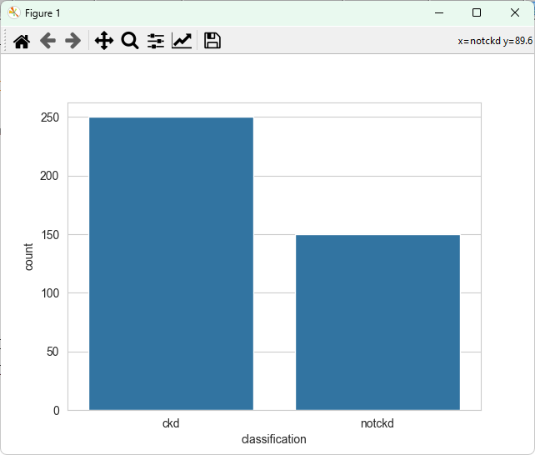

CLASSIFICATION OF HEMO VERSUS WC

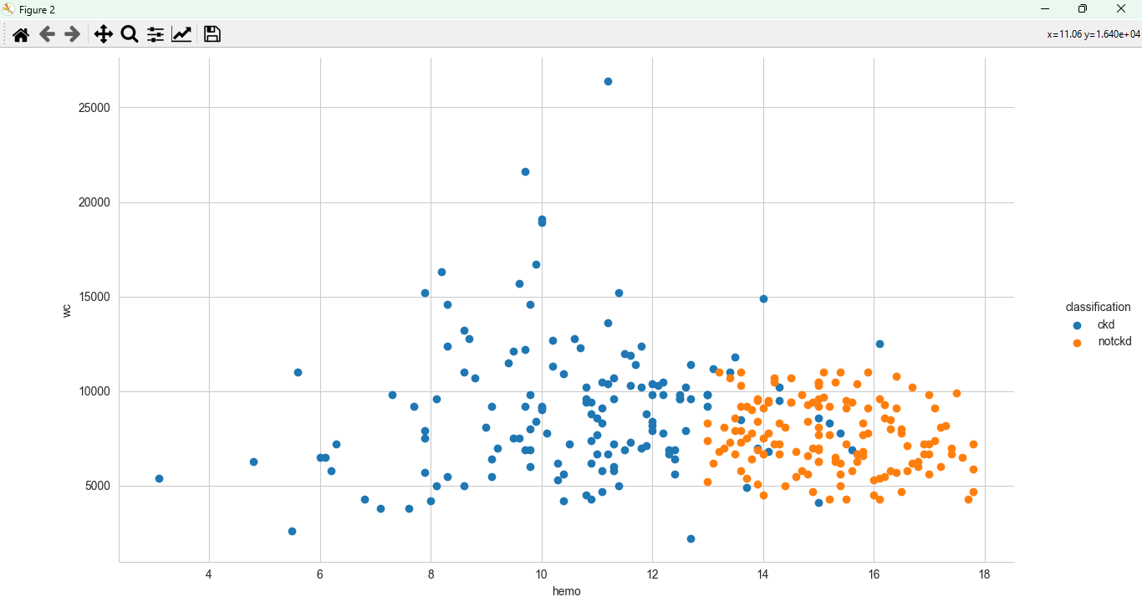

CLASSIFICATION OF HEMO VERSUS RC

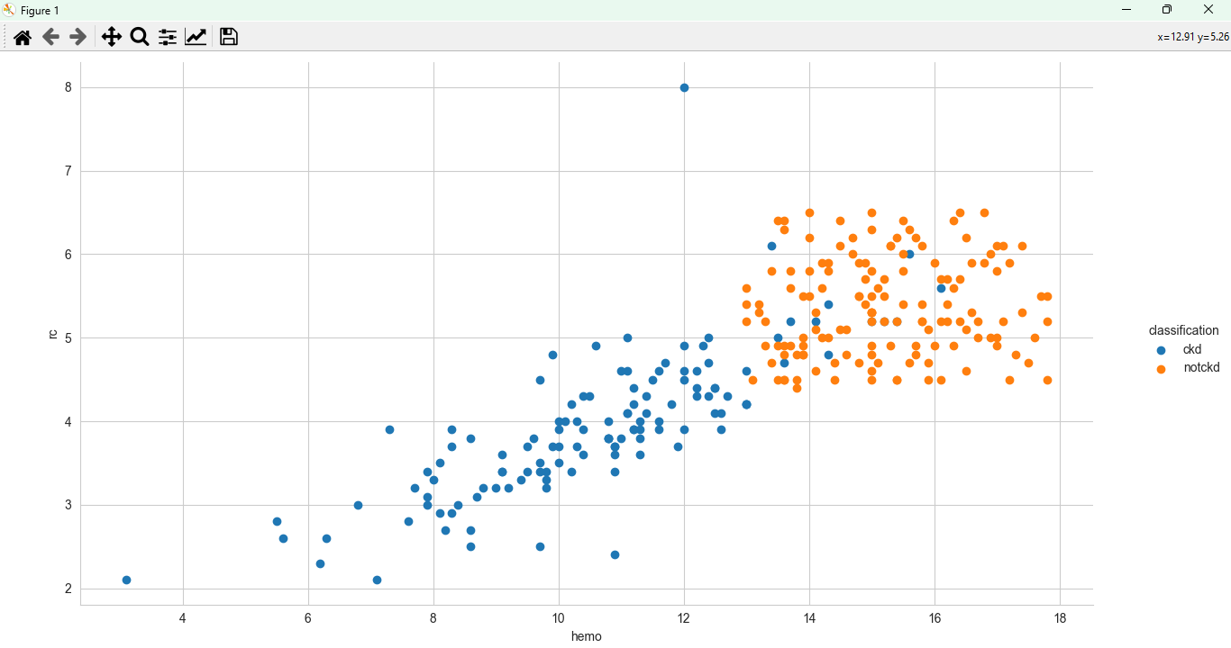

CLASSIFICATION OF (HEMO, WC) VERSUS BGR

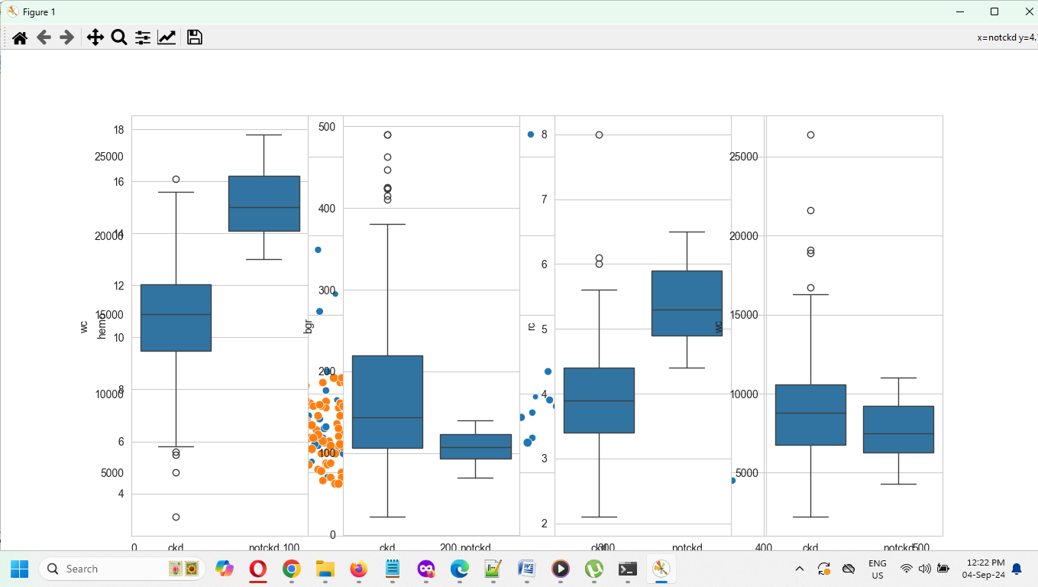

CLASSIFICATION OF CKD VERSUS NOTCKD FOR HEMO, WC, RC, BGR

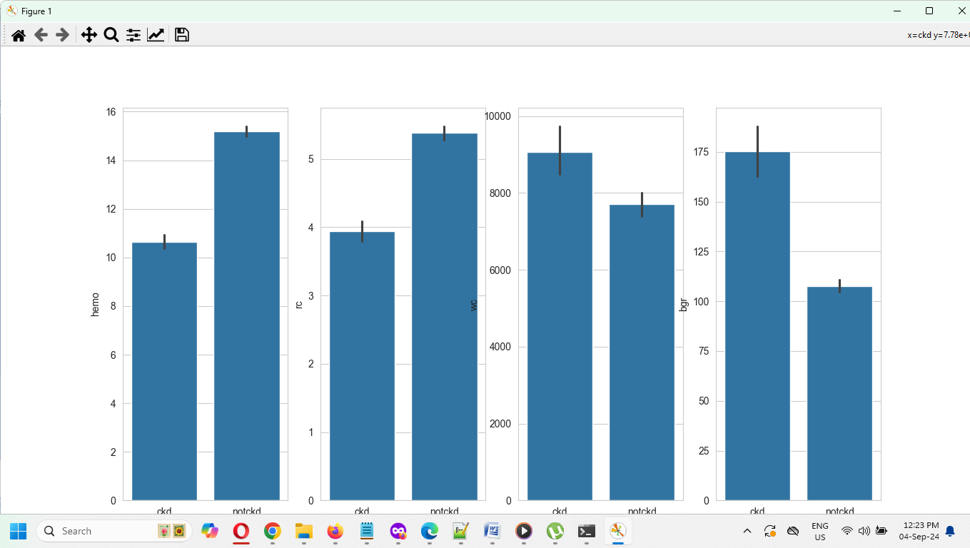

CLASSIFICATION OF CKD VERSUS NOTCKD FOR HEMO



CLASSIFICATION OF COMPONENT1 AND COMPONENT2

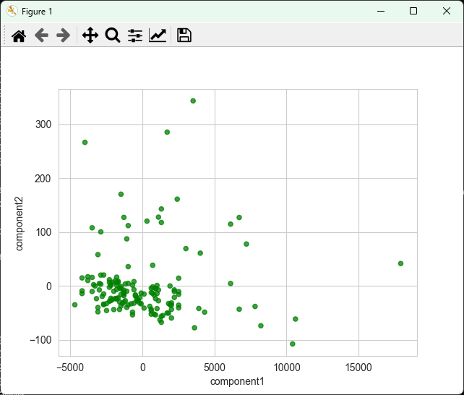

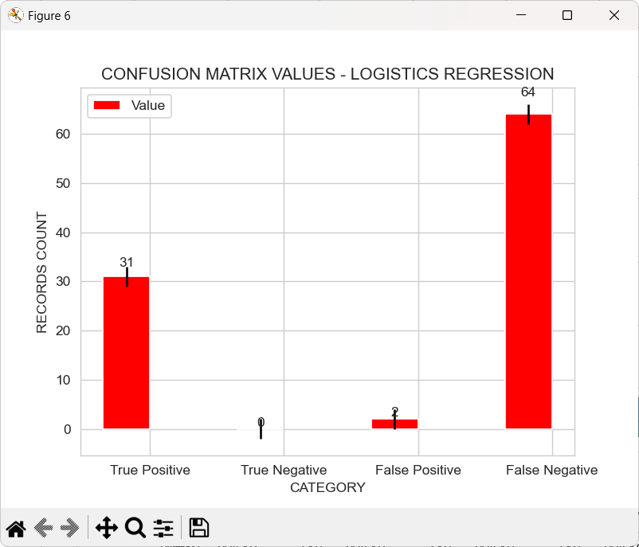

Sample records:

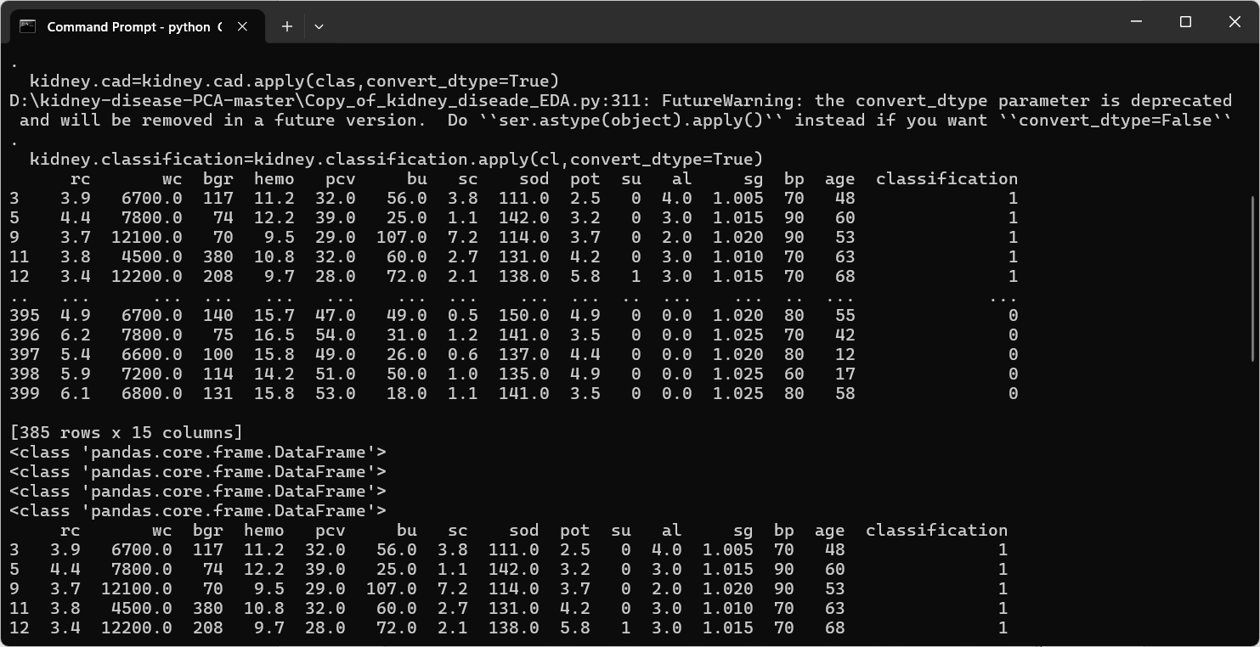

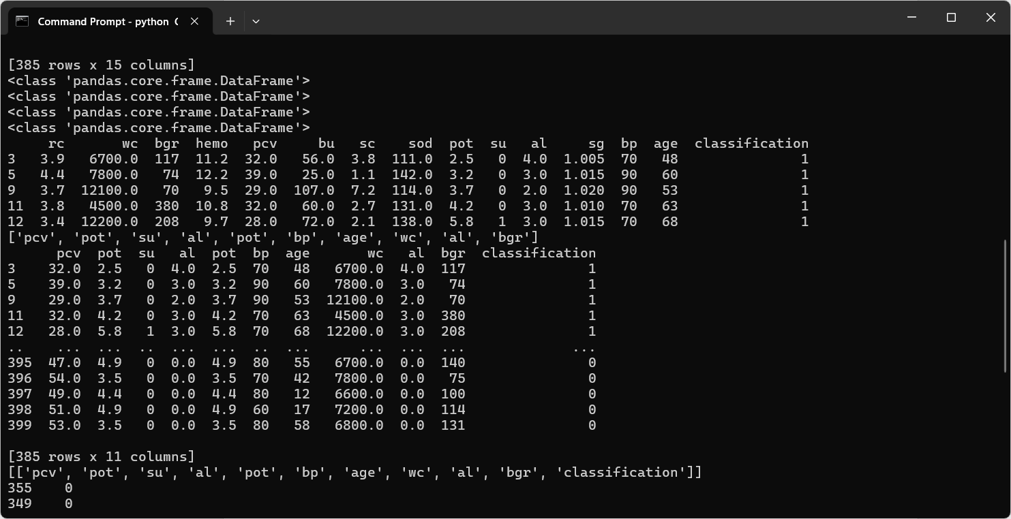

After logistic regression

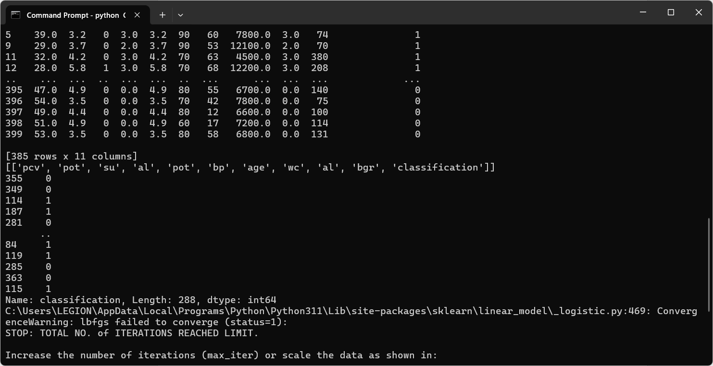

Logistic regression – accuracy score

